RECYCLABLE WASTE CLASSIFICATION USING DEEP LEARNING

Mr. R. RAKESH, M.E₁, Mrs. P. ANITHA, M.E2,
S. ABINAYA, V. SWETHA
₁ Assisstant Professor, Department of Information Technology, Paavai Engineering College, India
E-mail: mail2itrakesh@gmail.com
₂ Assisstant Professor, Department of Information Technology, Paavai Engineering College, India
E-mail: anithapalanivelpec@paavai.edu.in
₃Department of Information Technology, Paavai Engineering College, India
E-mail: abinayastalin89@gmail.com
₄Department of Information Technology, Paavai Engineering College, India
E-mail: swethav389@gmail.com

Abstract— This project addresses the challenge of inefficient manual waste classification by proposing an automated system using the VGG deep learning architecture. A convolutional neural network, trained on a large, augmented dataset of waste images (paper, plastic, glass, metal, organic), is developed to accurately classify waste. The model's performance is evaluated against state-of-the-art methods, demonstrating its effectiveness in improving waste management practices and reducing environmental pollution through accurate and efficient waste classification.

Index Terms— Machine Learning, Deep Learning, VGG Architecture, Convolutional Neural Network (CNN), Smart Waste Classification, Test Dataset, Automated Classification.

INTRODUCTION

The smart waste classification is an emerging field that focuses on using machine learning techniques to automate waste classification based on images. The process involves collecting and preprocessing a large dataset of waste images, which are then labelled and used to train a deep learning algorithm. The trained model is then used to classify new waste images into different categories, such as paper, plastic, glass, metal, and organic.Smart waste classification has several advantages over traditional methods of waste classification. It is highly accurate, efficient, and can handle a large number of images in a short amount of time. It can also be customized to suit different waste classification requirements and can be extended to other types of waste classification tasks, such as hazardous waste classification,

medical waste classification, and electronic waste classification.Smart waste classification has the potential to significantly improve waste management practices and reduce environmental pollution. It can help reduce the time and resources required for manual waste classification, which can
lead to more efficient and cost-effective waste management practices.

Deep Learning
Deep Learning is a subset of machine learning that involves training artificial neural networks with multiple layers to recognize patterns in data. Deep learning algorithms can be used for a wide range of tasks such as image and speech recognition, natural language processing, and even playing games like Go and Chess. The main advantage of deep learning over traditional machine learning approaches is its ability to automatically learn features from raw data without the need for manual feature engineering. This is accomplished by stacking multiple layers of neurons, each of which performs a nonlinear transformation of the input data. The output of one layer serves as the input for the next layer, allowing the network to gradually learn increasingly complex representations of the input data. Popular deep learning algorithms include Convolutional Neural Networks (CNNs) for image and video processing, Recurrent Neural Networks (RNNs) for sequential data processing such as natural language processing, and Generative Adversarial Networks (GANs) for generating realistic images and videos. Training deep learning models requires large amounts of labeled data and significant computational resources. However, recent advancements in hardware and software have made it easier to train deep learning models on a wide range of applications. Deep learning algorithms are based on artificial neural networks, which are inspired by the structure and function of the human brain. The networks consist of layers of interconnected nodes, or neurons, that process information in a hierarchical manner. The input data is fed into the first layer of the network, which extracts basic features. The output of this layer is then passed to the next layer, which extracts more complex features based on the previous layer's output, and so on.

Experimentation

Datasets Collection
Dataset acquisition refers to the process of obtaining data for use in various applications, such as machine learning, data analysis, and research.In this module, we can input the pest datasets that are collected from KAGGLE web sources. There are several publicly available datasets for waste classification, such as the UCI waste classification dataset, the TrashNet dataset, and the DUST dataset. These datasets can be accessed online and used for training and testing the model.It's important to ensure that the datasets used for training and testing the model are diverse and representative of the waste that the system will be classifying in real-world scenarios. This can help ensure that the model is able to accurately classify waste under a range of different conditions.

Preprocessing
In smart waste classification using VGG16 CNN, image preprocessing is a crucial step in preparing the data for training and testing the model. The first step in image preprocessing is to load the images from the dataset using a Python library like OpenCV or PIL. Once the images are loaded, they may need to be resized to a specific dimension before being used in the model. This is important to ensure that all the images have the same size, which is required for the VGG16 CNN architecture.

Features Extraction
In smart waste classification using VGG16 CNN, feature extraction is the process of extracting meaningful features from the pre-processed images. This is achieved by using the convolutional layers of the VGG16 CNN model, which are designed to identify patterns and features within the images. The convolutional layers consist of filters that are trained to recognize specific features, such as edges, corners, and curves. As the images are passed through the convolutional layers, these filters extract relevant features and create feature maps that highlight the presence of these features in the images.The output of the convolutional layers is then flattened into a vector and passed through a series of fully connected layers, which act as a classifier and make the final prediction about the class of the image.
D. Model Training And Waste Classification
Once the preprocessed images have been passed through the VGG16 CNN model for feature extraction, the next step is to train the model to accurately classify the images into their respective waste categories. This is done using a technique called supervised learning, where the model is trained on a labeled dataset consisting of images and their corresponding waste categories.During training, the VGG16 CNN model adjusts its parameters to minimize the difference between the predicted class labels and the true class labels. This process involves backpropagating the error from the output layer to the input layer, and adjusting the weights of the model to improve its performance on the training data.The training process involves dividing the dataset into two subsets: a training set and a validation set. The training set is used to train the model, while the validation set is used to monitor the performance of the model and prevent overfitting.During training, the model is evaluated on the validation set after every epoch to track its performance and prevent overfitting.

Proper waste classification is important for effective waste management, as it enables the identification of appropriate disposal methods and the implementation of measures to minimize the environmental impact of waste.In this module classify the waste using CNN framework and it includes the steps as
- Validate the model: Evaluate the model's performance on the validation data to avoid overfitting and to ensure that the model is generalizing well to new data.
- Fine-tune the model: Based on the validation performance, adjust the model architecture, hyperparameters, or training procedure to improve the model's performance. Repeat this process until the desired accuracy is achieved.
- Test the model: Finally, evaluate the model's performance on a separate test set to obtain an unbiased estimate of its performance on unlabeled data.
Finally provide the recognized waste name

System Architecture
A deep learning approach to waste classification begins with dataset collection, specifically sourced from Kaggle, providing a diverse set of waste images. These images undergo preprocessing to filter out noise, ensuring data quality for training. The preprocessed data is then split into training and testing sets. Feature extraction, a critical step in deep learning, identifies key characteristics within the images. These extracted features are used to train a Convolutional Neural Network (CNN) algorithm. The trained model is then used to classify new, unseen waste images, predicting whether they are organic or recyclable. This process essentially automates waste sorting by leveraging deep learning.
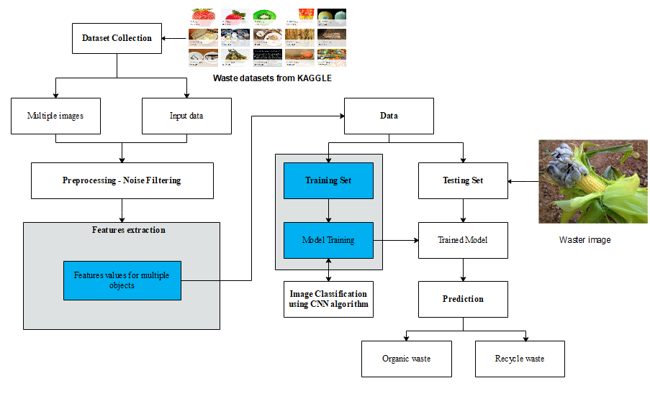
Fig 1. Architecture Of Waste Classification

VGG16 is a convolutional neural network (CNN) architecture named after the Visual Geometry Group at Oxford. It's renowned for its simplicity and effectiveness in image classification tasks. Its architecture features a stack of convolutional layers with small 3x3 filters, which allows it to learn intricate patterns and features in images. These convolutional layers are followed by max-pooling layers that reduce the spatial dimensions, controlling overfitting. VGG16 gained popularity for its impressive performance on the ImageNet challenge, a large-scale image recognition competition. It has since become a widely used model in various computer vision applications, including object detection, image segmentation, and even transfer learning, where its pre-trained weights are used as a starting point for new tasks.

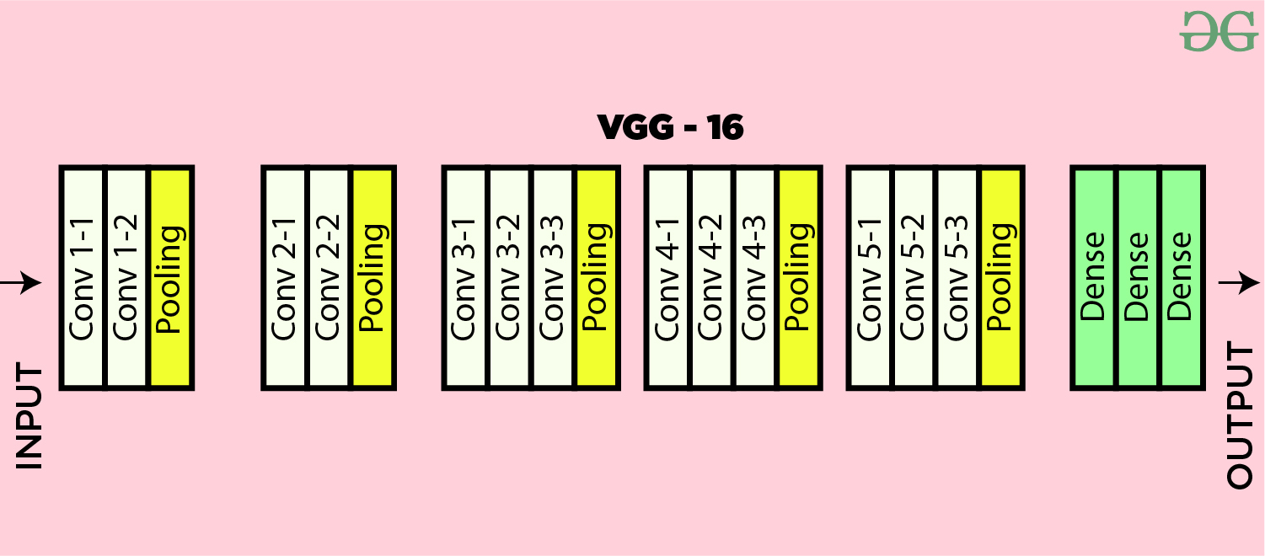

Fig 2. Architecture Of VGG-16

The VGG16 algorithm classifies images through a series of steps. First, the input image is fed into the network's convolutional layers, which extract features like edges and textures. Max pooling layers then reduce the size of these feature maps, making the network more robust to variations in the image. The output is flattened and passed through fully connected layers, which learn complex relationships between the features. Finally, a softmax layer assigns probabilities to each possible class, and the class with the highest probability is chosen as the predicted label for the input image

QUANTITATIVE EVALUATION
In this study, we have used a variety of deep learning models to classify six distinct waste categories, including cardboard, glass, plastic, paper, metal, and debris. To properly evaluate the performance of our models, we have employed established evaluation metrics that include precision, recall (sensitivity), specificity, and the F1 score. In this evaluation, these metrics were computed using data extracted from the confusion matrix, which contains crucial parameters such as true positives (TP), true negatives (TN), false positives (FP), and false negatives (FN). Notably, these metrics were accompanied by confidence intervals (CIs) of 95%, a crucial measure of the dependability and robustness of our evaluation outcomes. The confidence interval (CI) for each evaluation metric was calculated using the formulation outlined.

discussion
Traditional methods, relying heavily on manual sorting, are increasingly inadequate for managing the growing volume and complexity of global waste. This project leverages the power of deep learning, specifically the VGG architecture, to automate this critical process. VGG, known for its robust performance in image recognition, is employed here to train a Convolutional Neural Network (CNN). This CNN is designed to analyze images of waste and categorize them into distinct classes like paper, plastic, glass, metal, and organic. The use of a large dataset, coupled with preprocessing and augmentation techniques, ensures the model's accuracy and ability to generalize across diverse waste items. By automating waste classification, this project offers significant potential benefits. It can streamline waste management operations, reducing the time and labor required for sorting. More importantly, accurate classification ensures that waste is directed to the appropriate processing streams, maximizing recycling and resource recovery while minimizing environmental pollution. The proposed method's evaluation against existing state-of-the-art solutions underscores its effectiveness. The results highlight the potential of deep learning in revolutionizing waste management practices, paving the way for a more sustainable and efficient approach to handling the world's growing waste problem. This technology could be integrated into smart bins, robotic sorting systems, or even mobile apps, empowering individuals and industries to contribute to a cleaner environment.

CONCLUSION
The Smart Waste Classification system using VGG16 CNN is an efficient approach towards automatic waste classification using deep learning techniques. The proposed system aims to solve the issue of improper waste management by classifying waste materials into different categories. The VGG16 architecture has been used for the proposed system as it is a powerful and widely used architecture in image classification. The system requires pre-processing of the images for enhancing the quality of the input images. The images are then trained using the VGG16 CNN model, and the features are extracted to perform waste classification. The proposed system has various advantages such as high accuracy, reduced human intervention, and better waste management. The system can handle large datasets and can classify the waste into different categories with high accuracy, which helps in waste management and recycling. Compared to existing waste classification algorithms, the proposed VGG16-based system showed better accuracy and robustness. The VGG16 architecture, with its deep layers and ability to learn complex features, proved to be a powerful tool in image classification tasks.Overall, the proposed system has great potential for real-world waste management applications, enabling efficient and effective sorting of waste materials for proper disposal or recycling. Future work can involve expanding the dataset to include more diverse waste materials, optimizing the hyperparameters of the VGG16 algorithm, and implementing the system in a practical waste management setting.

References
- Sami, Khan Nasik, Zian Md Afique Amin, and Raini Hassan. "Waste management using machine learning and deep learning algorithms." International Journal on Perceptive and Cognitive Computing 6.2 (2020): 97-106.
- Shahab, Sana, Mohd Anjum, and M. Sarosh Umar. "Deep learning applications in solid waste management: A deep literature review." International Journal of Advanced Computer Science and Applications 13.3 (2022).
- Sarker, Nibir, et al. "Illegal trash thrower detection based on hogsvm for a real-time monitoring system." 2021 2nd International Conference on Robotics, Electrical and Signal Processing Techniques (ICREST). IEEE, 2021.
- Majchrowska, Sylwia, et al. "Deep learning-based waste detection in natural and urban environments." Waste Management 138 (2022): 274-284.
- Nnamoko, Nonso, Joseph Barrowclough, and Jack Procter. "Solid waste image classification using deep convolutional neural network." Infrastructures 7.4 (2022): 47.
- Toğaçar, Mesut, Burhan Ergen, and Zafer Cömert. "Waste classification using AutoEncoder network with integrated feature selection method in convolutional neural network models." Measurement 153 (2020): 107459.
- Lin, Kunsen, et al. "Deep convolutional neural networks for construction and demolition waste classification: VGGNet structures, cyclical learning rate, and knowledge transfer." Journal of Environmental Management 318 (2022): 115501.
- Spyridakos, Athanasios, et al. "Waste classification of spent refractory materials to achieve sustainable development goals exploiting multiple criteria decision aiding approach." Applied Sciences 12.6 (2022): 3016.
- Windrim, Lloyd, et al. "Unsupervised ore/waste classification on open-cut mine faces using close-range hyperspectral data." Geoscience Frontiers 14.4 (2023): 101562.
- Bailey, G. W., M. R. Gilbert, and O. Vilkhivskaya. "Waste classification assessment of nuclear steels for fusion power applications." EPJ Web of Conferences. Vol. 247. EDP Sciences, 2021.

